**The Female Reproduction**

Knowing the anatomy of the reproductive area is essential for midwifery. The diagram you see is of a non-pregnant person from a side view.

**Activity:** Please now label the anatomy as best you can and then do a search on google to check your answers: This is printable.

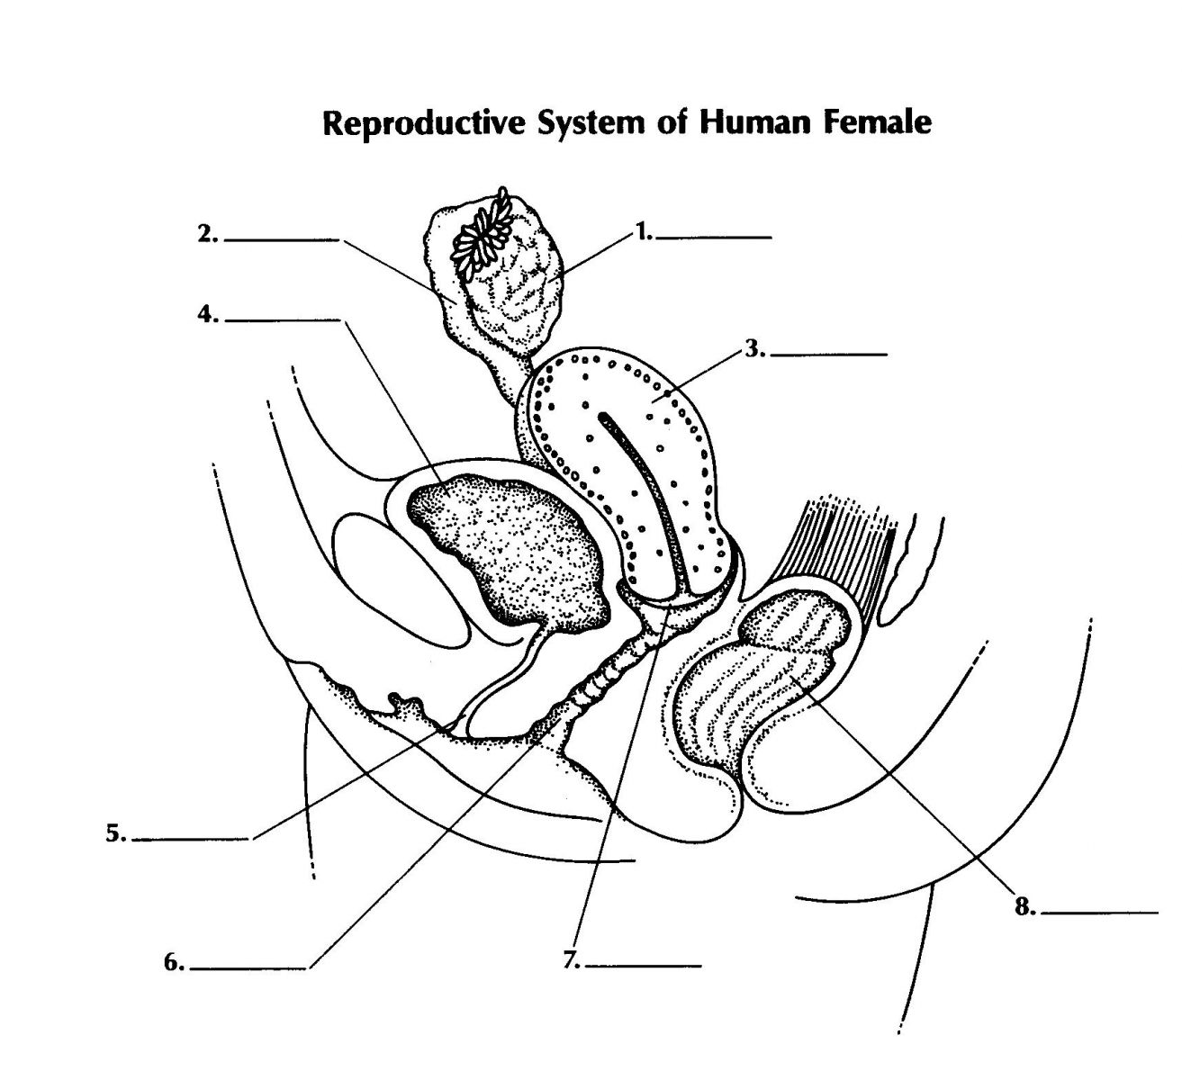

Cervix

Bowel

Ovary

Bladder

Urethra

Fallopian Tubes

Uterus

Vagina

**Where does the baby live and grow for approximately 40 weeks?**

**Before conception takes place where does the egg travel from and too?**